BUXTON / MICROSOFT COLLECTION
home | explore | associated narratives | about | acknowledgments | contact

Apple Adjustable Keyboard
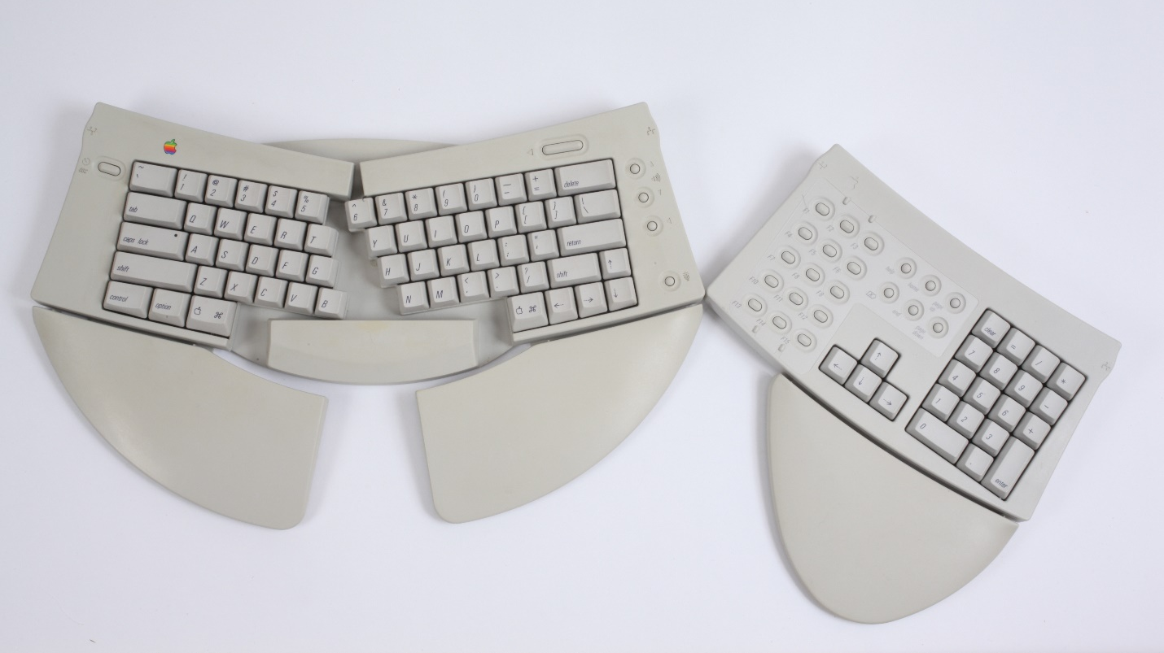
Short Description: This is Apple’s first ergonomic keyboard and keypad set. Both parts had removable palm rests, as well as fold-out legs which enabled limited tilt adjustment. As well, the main keyboard was split, with a hinge at the top middle which enabled the angle between the two halves to be adjusted to suit the angle of approach of the typist’s hands/forearms.

Bill Buxton’s Notes
This is Apple’s first ergonomic keyboard and keypad set. Both parts had removable palm rests, as well as fold-out legs which enabled limited tilt adjustment. As well, the main keyboard was split, with a hinge at the top middle which enabled the angle between the two halves to be adjusted to suit the angle of approach of the typist’s hands/forearms.
More to come..

Device Details
Company: Apple Computer | Year: 1992 | Original Price (USD): $219.00
Design: Apple Computer: Ray Riley & Harold Welch.
Degrees of Freedom: N/A
Dimensions (L x W x H – flip feet closed):
- Keyboard: 386.6 x 159 x 37.5 (mm) / 15.18” x 6.26” x 1.4”
- Keypad: 248.3 x 143.7 x 37.5 (mm) / 9.78 x 5.66” x 1.4”
Key Words
Primary: Keyboard
Secondary: Ergonomic, Keypad, Numerical Keypad
Links
- XXX

- Apple Adjustable Keyboard User's Guide

- powerpoint

- Vimeo video link

- XXX

Image | File Name | Caption
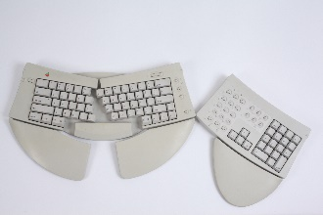 | Adjust_001.JPG | The Apple Adjustable Keyboard with its extended keypad shown with their removable palm rests attached.
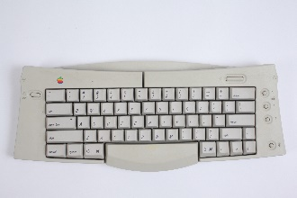 | Adjust_002.JPG | The Apple Adjustable Keyboard seen in straight configuration, that is not split and 0° opening angle.
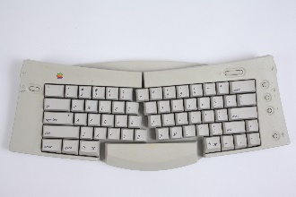 | Adjust_003.JPG | The keyboard beginning to split, with the angle between the two halves starting to open.
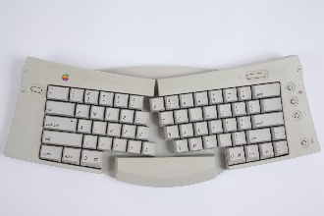 | Adjust_004.JPG | The angle between the two halves of the Apple Adjustable Keyboard opening even more.
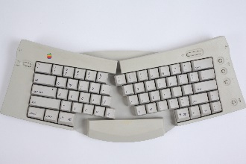 | Adjust_005.JPG | The Apple Adjustable Keyboard shown at the maximum, 30° opening angle.
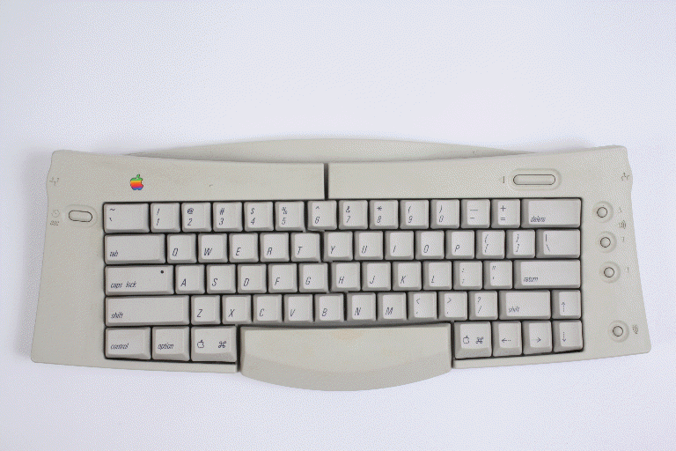 | Adjust_006.gif | An animation of the Apple Adjustable Keyboard opening and closing, showing the range from 30° to 30°.
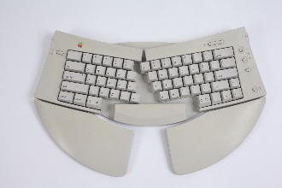 | Adjust_0041.JPG | The Apple Adjustable Keyboard with palm rests attached.
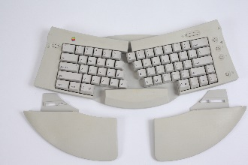 | Adjust_0044.JPG | The Apple Adjustable Keyboard showing the detached palm rests alongside.
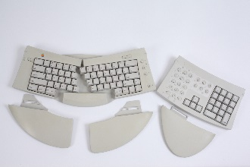 | Adjust_0045.JPG | The Apple Adjustable Keyboard with its extended keypad shown with their detached palm rests alongside.
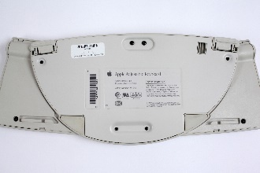 | Adjust_0050.JPG | A view of the under-side of the Apple Adjustable Keyboard.
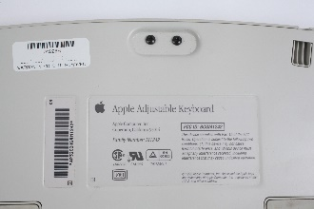 | Adjust_0051.JPG | Detail of the bottom of the Apple Adjustable Keyboard showing the product information.
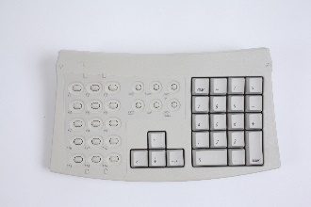 | Adjust_0053.JPG | The extended keypad of the Apple Adjustable Keyboard without its removable palm rest.
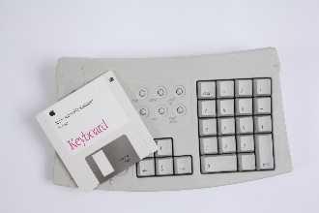 | Adjust_0054.JPG | The extended keypad of the Apple Adjustable Keyboard with the Installer Disk laid on top to give a sense of scale.
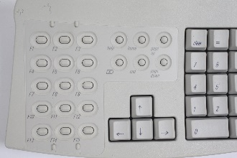 | Adjust_0055.JPG | A close-up of the extended keypad of the Apple Adjustable Keyboard highlighting the function keys (the arrow keys and part of the numerical keypad can also be seen). Notice the two little nipples above on either side of the F2 and below F14 keys. These are registration pins which enable application specific labels to be applied to these keys.
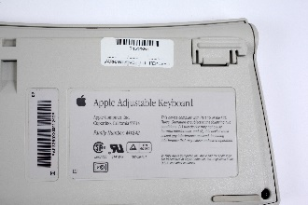 | Adjust_0056.JPG | A close-up shot of the under-side of the Apple Adjustable Keyboard’s extended keypad showing the product label details. In the upper-right corner, note also one of the keypad’s legs in folded folded-up position.
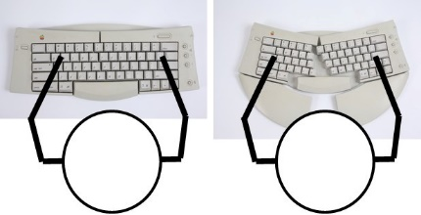 | Adjust_Ergo_Pair.jpg | A schematic image intended to show how the adjustability of the keyboard’s opening angle can potentially help reduce constriction around the wrist by keeping the main axis of the hand more in line with the forearm while typing.
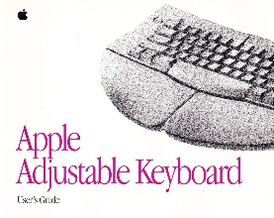 | Adjust_Keybd_Guide.jpg | Image of the cover of the Apple Adjustable Keyboard User’s Guide. To access the full document, click on the image.

WORK NOTES:
- Add shot showing application-specific function labels in place.
- Add cross reference to the Prohance Mouse and Trackball’s similar support of such labels.
- Check if I have any templates in the box.
- If not, search for some.

