BUXTON / MICROSOFT COLLECTION
home | explore | associated narratives | about | acknowledgments | contact

Braun AG T3 Transistor Radio
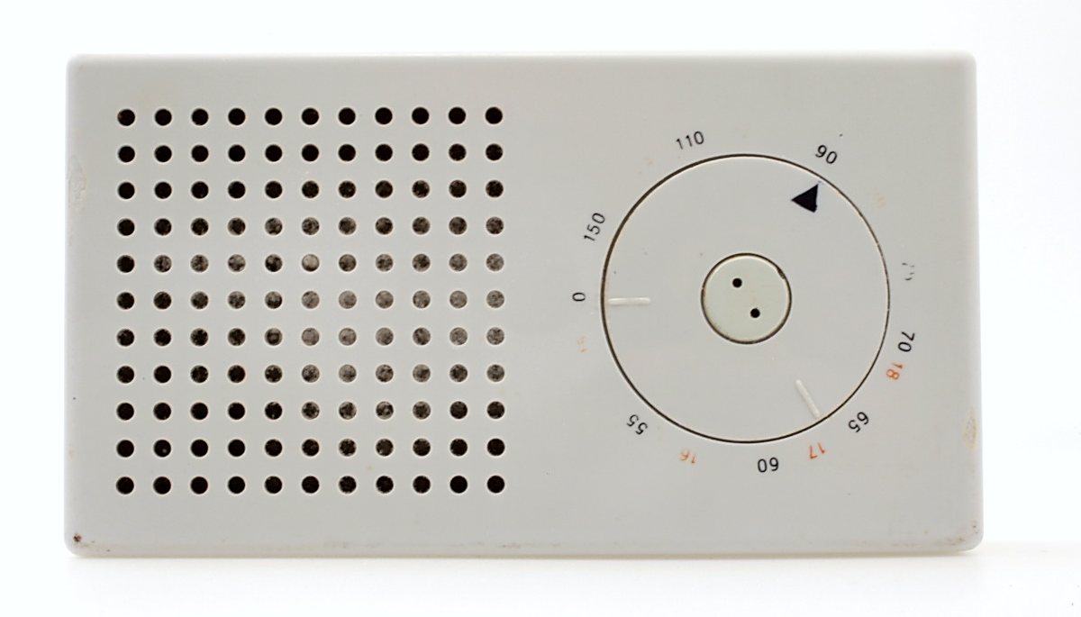
Short Description: The 1958 Braun T3 transistor radio, designed by Dieter Rams Dieter Rams in conjunction with the Ulm Hochschüle fur Gestaltung (School of Design). An excellent example of the international style of design of the mid-20th century, the T3 radio was the inspiration for the design language of the Apple iPod Classic.

Bill Buxton’s Notes
The 1958 Braun T3 transistor radio is a classic of the international design style prevalent in the mid-20th century. By its sparse clean lines, it shares characteristics of the style seen in another familiar example, the font Helvetic, which was designed the previous year.
The T3 radio was designed by a designer recruited by Braun in 1955, Dieter Rams, in collaboration with the Ulm Hochschüle fur Gestaltung. The design which resulted was the inspiration for the design language of the Apple iPod Classic. The connection is made more obvious if one views the radio rotated 90° clockwise, as in one of the accompanying photographs. Here one can easily see the the similarity of proportions, uniformity of colour, angle of corners, location of display (audio versus visual), and the use of a flush rotary wheel controller.

Device Details
Company: Braun AG | Year: 1958 | Original Price (USD): $28.57 / DM 120.
Degrees of Freedom: 2
Dimensions (L x W x H): 152 x 41 x 83 (mm) (6 x 1 5/8 x 3 ¼”)
Key Words
Primary: Radio
Secondary: Handheld, Reference Object

Links
- Radio Museum Data on T3: http://www.radiomuseum.org/r/braun_transistor_3_t3.html

Image | File Name | Caption
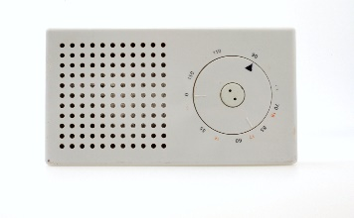 | BraunT3_H.JPG | Front view of the Braun T3 Transistor Radio.
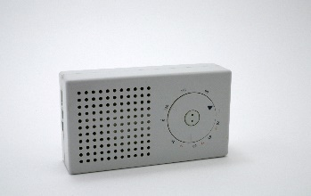 | BraunT3_2405.JPG | Upper left quarter view of the Braun T3 Transistor Radio.
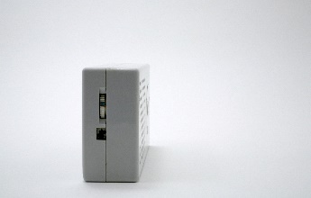 | BraunT3_2410.JPG | Side view of the Braun T3 Transistor Radio showing the recessed volume control.
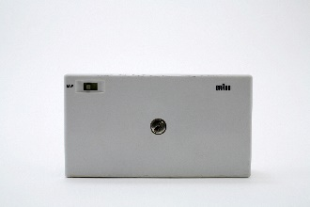 | BraunT3_2416.JPG | Back view of the Braun T3 Transistor Radio
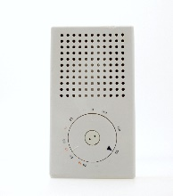 | BraunT3_V.JPG | Front view of the Braun T3 Transistor Radio rotated 90° clockwise.
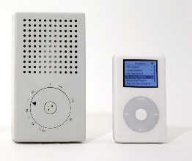 | T3+iPod.JPG | Braun T3 radio, rotated onto its side, beside the 4th generation iPod Classic, illustrating the common design language.
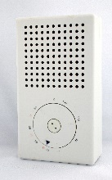 | BraunT3_0011.JPG | Front view of the Braun T3 Transistor Radio rotated 90° clockwise, from right side.
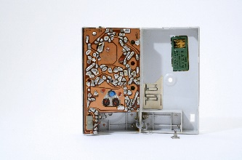 | BraunT3_2427.JPG | Overview of the interior electronics of the Braun T3 Transistor Radio.
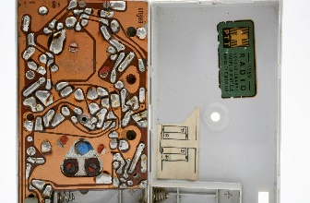 | BraunT3_2437.JPG | Close-up view of the interior electronics of the Braun T3 Transistor Radio
 | BraunT3_Technical_Info.jpg | Radio Museum web page with technical information of the Braun T3 Transistor Radio. (Click on image to access web page.

