BUXTON / MICROSOFT COLLECTION
home | explore | associated narratives | about | acknowledgments | contact

FingerWorks TouchStream LP
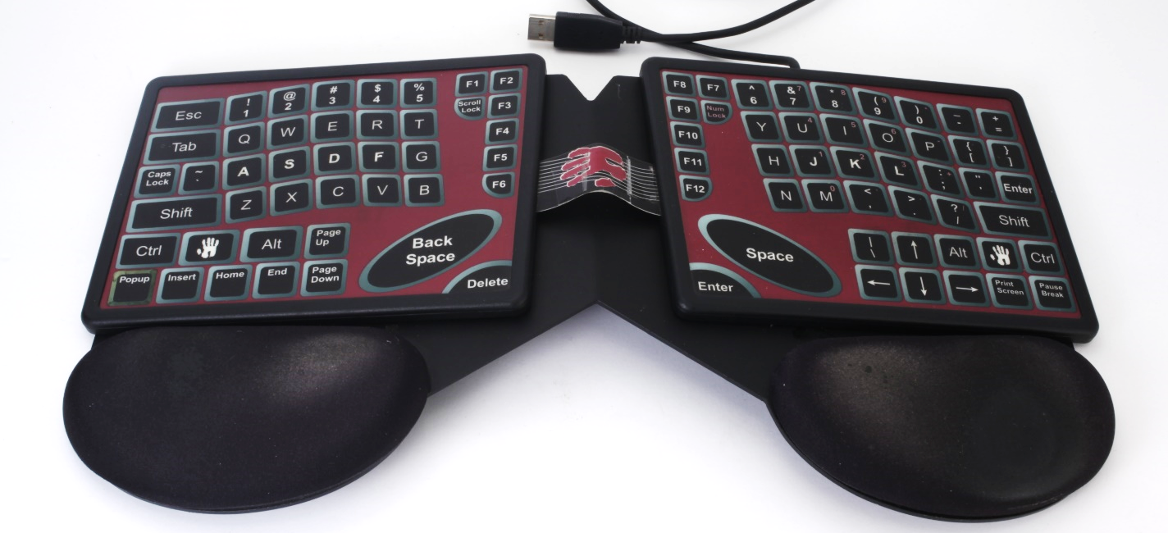
Short Description: The TouchStream is a keyboard based on a pair of multi-touch pads. These can sense key taps and finger gestures. The “keys” are graphic. They are flush with the pad and have no mechanical movement. There are however, small raised points to help position the hands on the keyboard eyes-free typing, but these still allow the fingers slide easily on the surface when gesturing, such as when emulating a mouse.. The keyboard is independent of the base. It can be folded in half for compact portability. It can also be placed conveniently over a laptop’s keyboard as a replacement which then also enables the gesture enhancements to be used on the road. Although not obvious to the eye, this is the core technology which, after being acquired by Apple, evolved into the iPhone’s multi-touch capability.

Bill Buxton’s Notes
Named FingerBoard during development, this product was relabeled TouchStream in October 2001 as the release date approached.when finally shipped, was renamed TouchStream

The very rare original stand for this device was a gift from Sean Gerety, Atlanta, GA.

Device Details
Company: FingerWorks | Year: 2002 | Original Price (USD): $339.00
Degrees of Freedom: 2
Dimensions (L x W x H): 180 x 140 x 9 (mm) - Each Half
Base: 410 x 220 x 30 (mm)

Key Words
Primary: Keyboard
Secondary: Foldable Keyboard, TouchPad, Multi-Touch, Gesture, Reskin
Links
- TouchStream Product Page Feb. 6th, 2002:
https://web.archive.org/web/20010515210657/http://www.FingerWorks.com/
- TouchStream Product Page Details:
https://web.archive.org/web/20020219151303/http://www.FingerWorks.com/stealth_product.html
- TouchStream Flash Gesture Animations: https://web.archive.org/web/20020221214929/http://www.FingerWorks.com/gesture_guide_mouse.htm
- TouchStream Gesture Guide: https://web.archive.org/web/20020205104851/http://www.FingerWorks.com/stealth_gesture_guide.html
- FingerWorks News: https://web.archive.org/web/20020419114324/http://www.FingerWorks.com/news.html
- MeetTheGeeks.org (Jan. 15, 2004): TouchStream LT Review: https://web.archive.org/web/20040115205812/http://hardware.meetthegeeks.org:80/ourreview/archives/FingerWorksTouchStream/
- extremeTech.com Week of Wackey Input Devices, April 21, 2003 (Includes: Safetype Keyboard, Quill Vertical Mouse, DataHand, TouchStreamLT, Microsoft Wireless Optical Desktop Pro Mouse, Z-Board: https://web.archive.org/web/20040605153251/http://www.extremetech.com/print_article/0,1583,a=40731,00.asp

Image | File Name | Caption
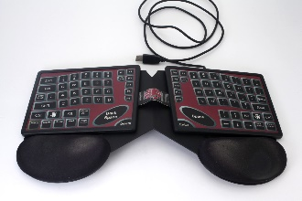 | TouchStream+Base_High.JPG | The TouchStream Keyboard positioned on its base.
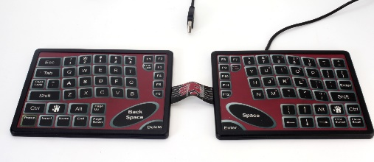 | TouchStream_Solo | The TouchStream Keyboard deployed flat, off of its base.
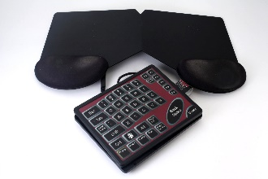 | TouchStream_Folded+Base.JPG | The TouchStream Keyboard folded in half beside its base stand.
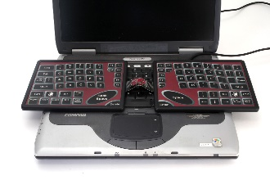 | TouchStream+PC2.JPG | The TouchStream Keyboard positioned to be used as an alternative to a laptop’s conventional built-in keyboard.
 | TouchStream+Base_High.JPG | A different angle view of the TouchStream Keyboard on its base, giving a better sense of its thickness and posture on the base.
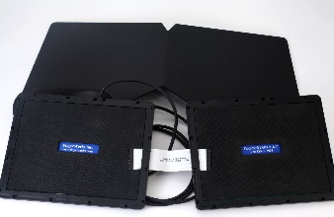 | TouchStream_Bottom.JPG | An under-side view of the TouchStream Keyboard, beside its stand, showing its serial number, etc.
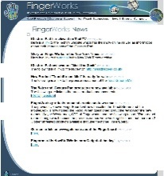 | FingerWorks_News.pdf | Snap of first page of FingerWorks News Webpage on April 1st, 2002. Click on image to access the full document.
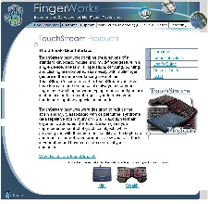 | TouchStream_Product_Page_2002_02_06.jpg | TouchStream web product page from Feb. 6th, 2002. . Click on image to access the full document.

