BUXTON COLLECTION
home | explore | about | acknowledgments | contact

Xerox PARC PARCtab
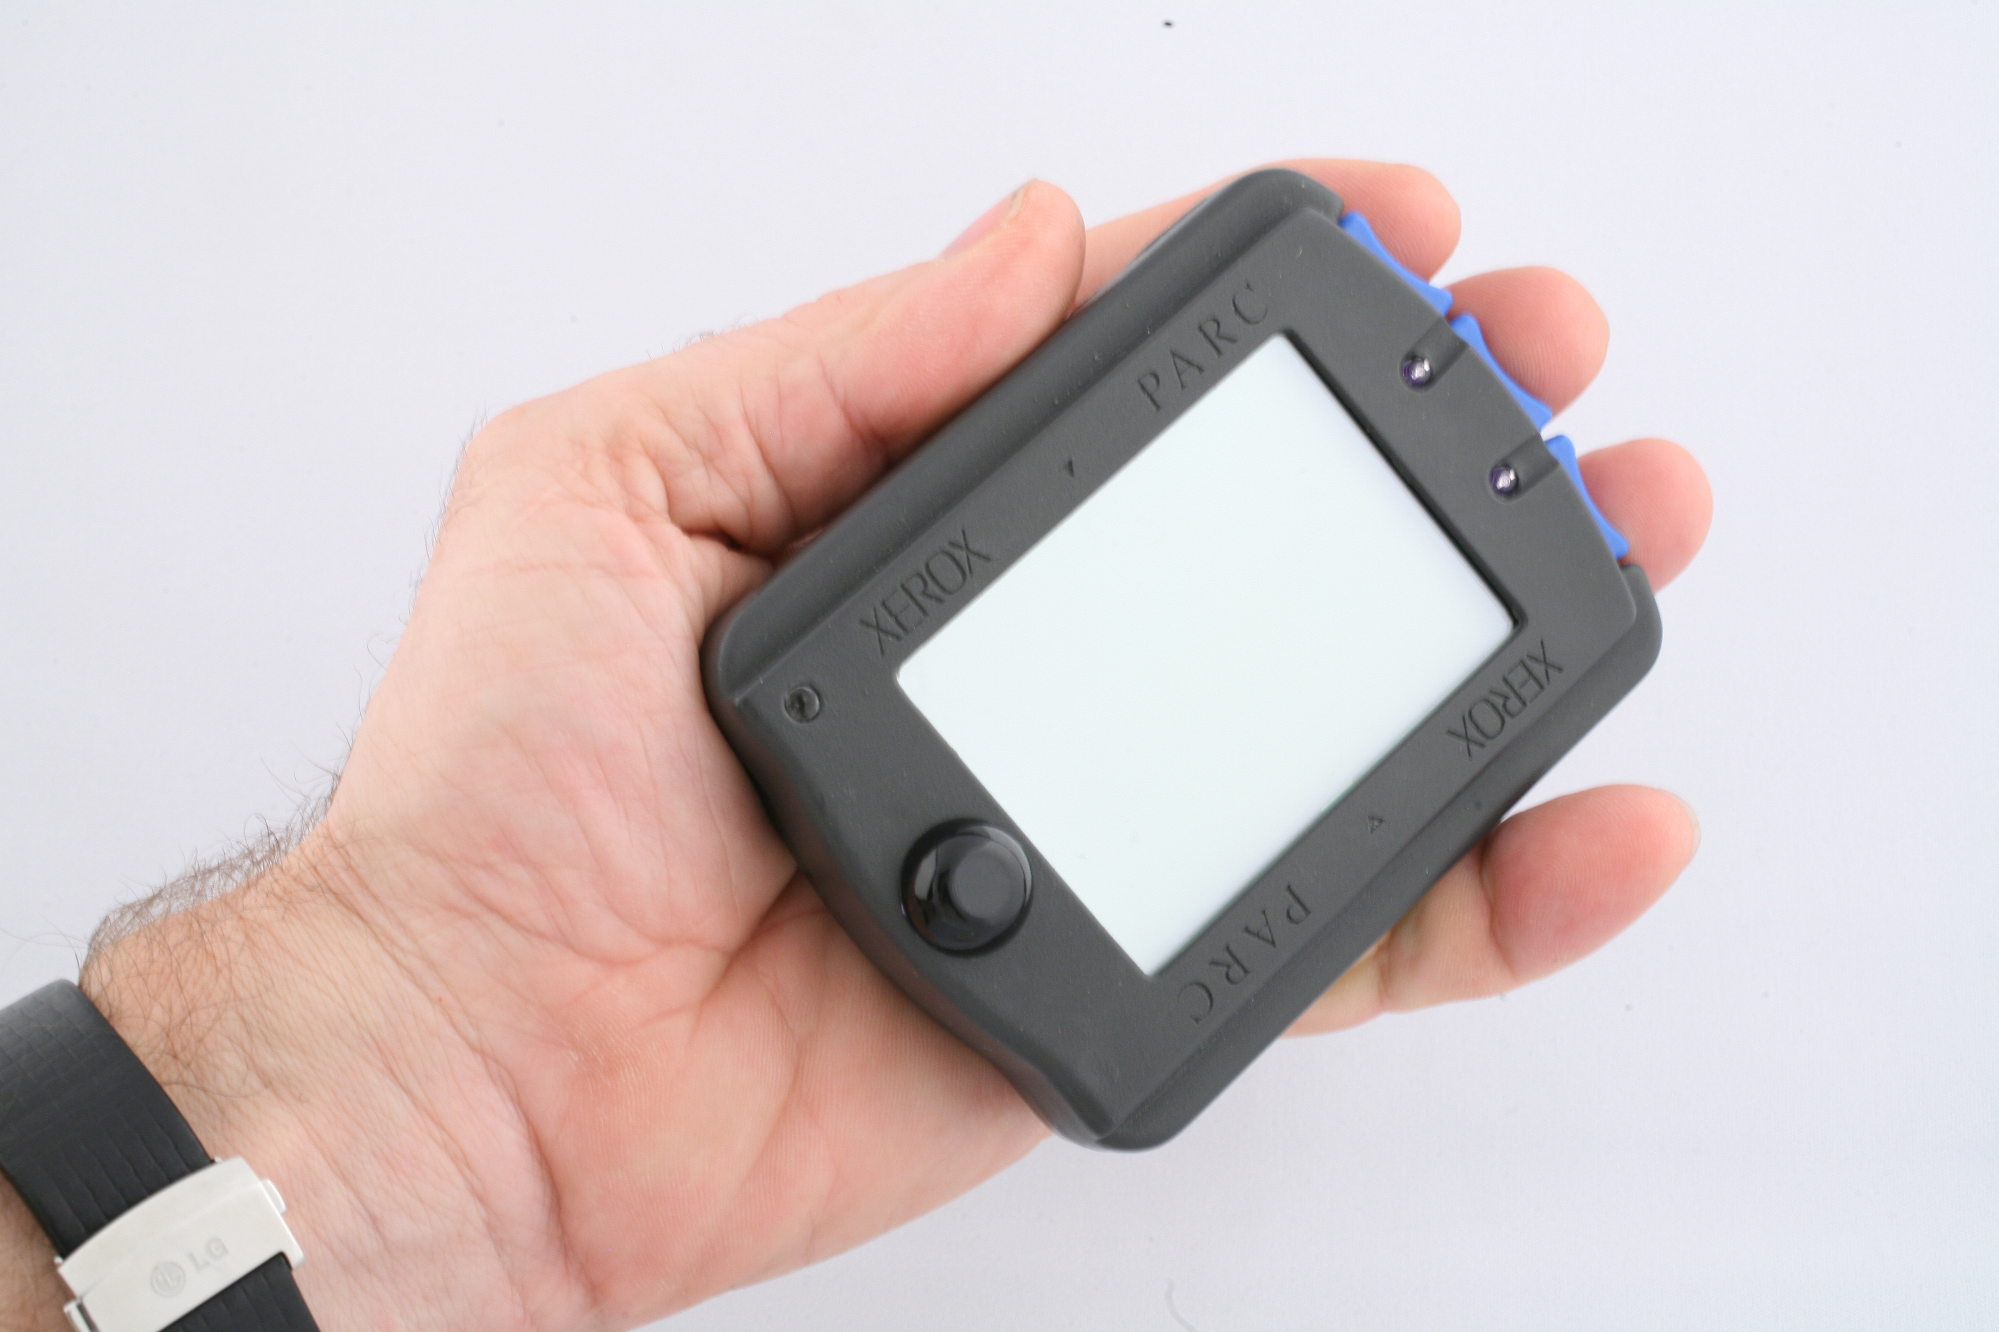
Short Description: This device is an important artifact of our early work on UbiComp at PARC. I had the button type and position designed after trumpet valves so that the buttons could be operated by the same hand holding the device, and also be chorded if desired.

Bill Buxton’s Notes
Put long description from web page here (note – most pages only have short description)
Device Details
Company: Xerox PARC | Year: 1992 | Original Price (USD): NFS

Links
- Web link

- The Xerox PARCTAB

- powerpoint

- you tube link

Image | Caption
PARCtab_1.jpg
PARCtab_1012.JPG
PARCtab_1013.JPG
PARCtab_1992.JPG
PARCtab_Xerox_info.jpg
PARCtab_Xerox_unistrokes.jpg
 | See the link below to access the pdf containing the full document.

Degrees of Freedom: 2
Type(s): Handheld, Chord Keyboard, Touch Screen, Stylus

NOTES:
- add image of liveboard and discuss society of appliances implications / rationale driving the design.

- price?
- Do you want to crop image to remove LG watch wristband?
- http://www.cs.colorado.edu/~rhan/CSCI_7143_002_Fall_2001/Papers/Want95_PARCTab.pdf
- http://www.roywant.com/cv/papers/pubs/1993-10%20(WWOS)%20parctab.pdf
- http://www.sciencephoto.com/media/349069/view
- https://cseweb.ucsd.edu/classes/sp00/cse221/reports/luc-ngu-tam-wan.pdf
- https://books.google.ca/books?id=c9F4ebT55DYC&pg=PA80&dq=Xerox+PARCtab&hl=en&sa=X&ei=HvA3Vf6_F8WkyAT4_IDQDQ&ved=0CC8Q6AEwAQ#v=onepage&q=Xerox%20PARCtab&f=false

