BUXTON COLLECTION
home | explore | about | acknowledgments | contact

Philco Mystery Control
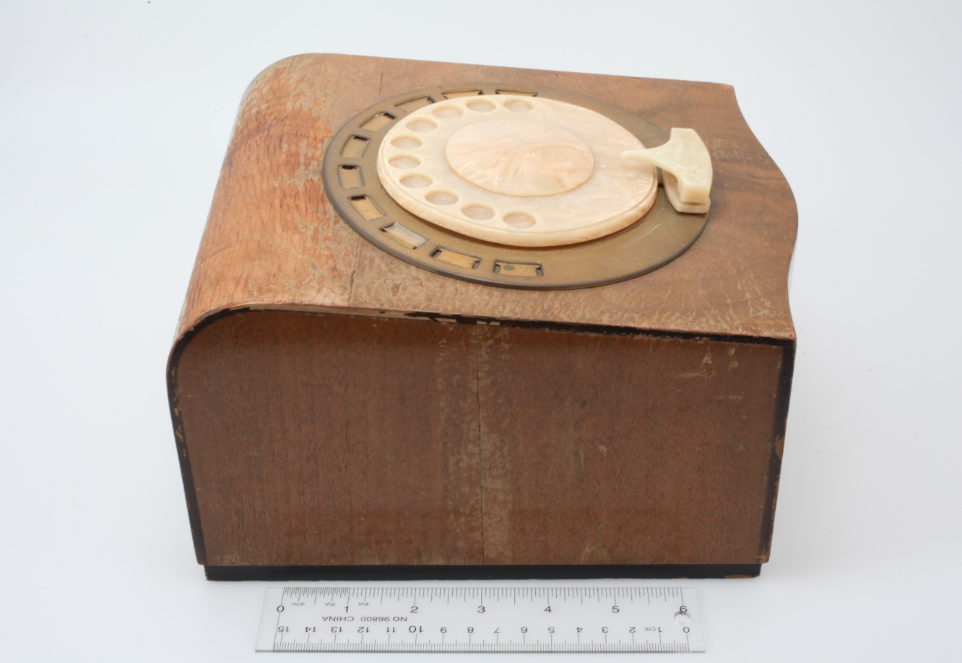
Short Description: Released in 1939, the Mystery Control was the world’s first commercially available wireless remote control for home entertainment. Its primary purpose was to permit you to control your radio from wherever you were sitting, without being encumbered by a connecting wire between and the radio. In this capacity, it could be used to turn the radio on and off, change stations, and control the volume. If the unit being controlled also incorporated a record player, the Mystery Control could also let you switch between it and the radio, as well as stop playing the current record, and drop the next one stacked on the spindle to play.
Bill Buxton’s Notes
Released in 1939, the Mystery Control was the world’s first commercially available wireless remote control for home entertainment. Its primary purpose was to permit you to control your radio from wherever you were sitting, without being encumbered by a connecting wire between and the radio. In this capacity, it could be used to turn the radio on and off, change stations, and control the volume. If the unit being controlled also incorporated a record player, the Mystery Control could also let you switch between it and the radio, as well as stop playing the current record, and drop the next one stacked on the spindle to play.
Viewed with today’s eyes, what most stands out about the Mystery Controller is its size – it is much larger than any remote that I had ever seen previously – and the fact that it used what appears to be a telephone dial as the means to interact with it. This latter was surprising to me, and I suspect even more-so to later generations who did not grow up with dial phones.
The easiest way to explain this today is be analogy. The Mystery Controller uses a phone dial as the controller for the same reason that after the Apple iPhone was released in 2007, every new gadget seemed to have to have a touch screen for control. In short, for both cases, it was cool.
In the case of the 1939 Mystery Control, the iconic product which made the phone dial cool was the 1937 launch of the Western Electric 302 telephone, designed by Henry Dreyfuss (which is in the collection) Dial telephones were not new. Western Electric began deploying them in 1919, which is when the launched the 50AL “Candlestick” Dial Phone (also in the collection). Even before that, dial phones had been deployed for over 20 years in smaller private exchanges.
So if Alexander Graham Bell and Thomas A. Watson made their famous telephone call in 1876, dial phones started to appear in the 1890s, and Western Electric started to deploy them in 1919, why was the 302 telephone a big deal in 1937, 60 years after Bell and Watson’s call, and 18 years after the Western Electric AL Candlestick dial phone?
The simple answer is, infrastructure. A dial phone is of no value if there is not a network capable of decoding the signals from the caller’s dial such that all of the switches along the way are automatically set to route the call to the intended recipient’s phone. The bigger the network the longer this takes. And once automated switches are in place, phones need to be deployed, users need to learn how to operate them, and service people need to be trained to service them.
Furthermore, to make things take even longer, one must take into account that 1930 signaled the beginning of the great depression. Few could afford phones, even if they were available, and they weren’t available as the financial resources to deploy the infrastructure were less than plentiful.
And finally, while the 50AL Candlestick phone was good for its time, its time was rapidly passing, and the introduction of the 302 telephone made a significant difference. The main one was that it was the first self-contained integrated phone. Yes, the Candlestick phones look wonderful, but they are only the microphone, speaker and dial. The electronic guts of the phone are in a completely separate box screwed to the wall somewhere. With the 302, the who thing was in one package which could be easily unplugged from one location and plugged in at another.
In short, it took until after 1937 for automated telephone exchanges and dial phones to start to approach critical mass. But there was still a long way to go. If you search on-line, you can easily find television instructional videos from the 1950s which teach how to dial a phone!
So yes, as archaic and arcane as the Mystery Controller appears today, it reflected the coolness of the emerging modern future emerging out of the depression. And, within the collection, it is one of the items which most consistently makes me smile every time I see it.
.
Device Details
Company: Philco | Year: 1939 | Original Price (USD): N/A
Degrees of Freedom: 1
Key Words
Primary: Remote Control
Additional: Dial, Reference Object
Links

- YouTube demo:
https://www.youtube.com/watch?v=5SDWNGrm9Gk

Image | File Name | Caption
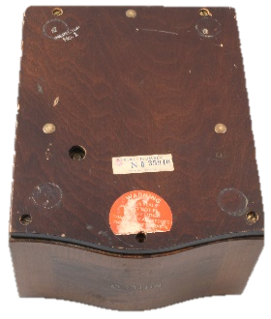 | Philco_Mystery_Bottom.JPG | Philco Mystery Control (1939): Bottom View
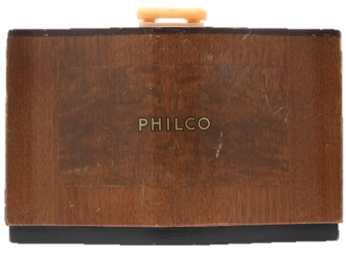 | Philco_Mystery_Front.JPG | Philco Mystery Control (1939): Front View
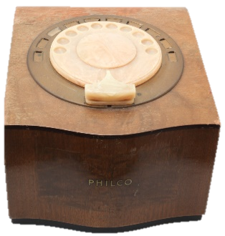 | Philco_Mystery_Front_Qtr.JPG | Philco Mystery Control (1939): Front Quarter View
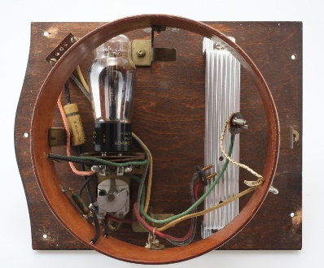 | Philco_Mystery_Inside_Lower.JPG | Philco Mystery Control (1939): Inside View of Base
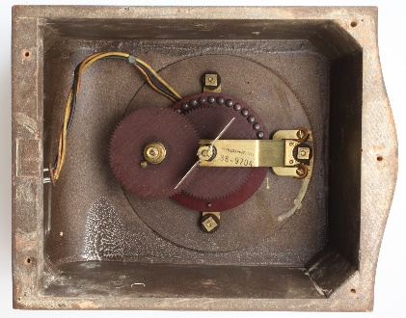 | Philco_Mystery_Inside_Upper.JPG | Philco Mystery Control (1939): Upper View Inside of Box
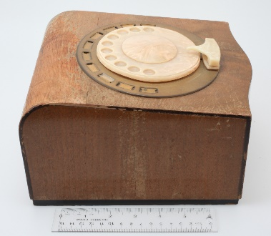 | Philco_Mystery_L_Side.JPG | Philco Mystery Control (1939): Left Quarter View
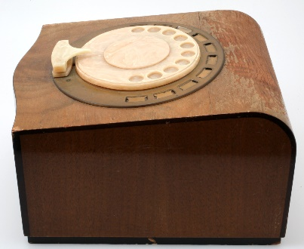 | Philco_Mystery_R_Side.JPG | Philco Mystery Control (1939):Right Quarter View
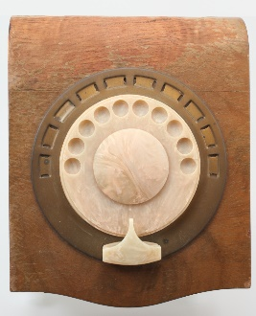 | Philco_Mystery_Top.JPG | Philco Mystery Control (1939): Top View
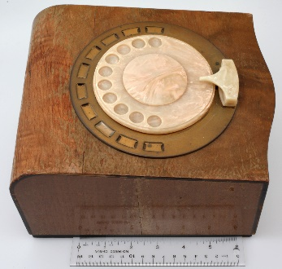 | Philco_Mystery_Top_Left_Quarter.JPG | Philco Mystery Control (1939): Top Left Quarter View
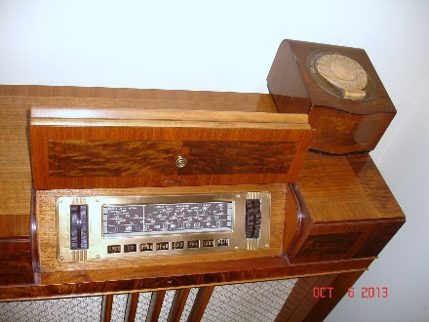 | Philco_116RX radio.jpg | Philco 116RX Radio with Mystery Control (1939). (Photo from web- needs credit & permission)
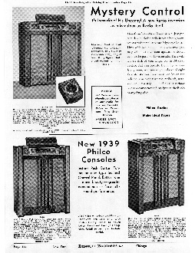 | Philco_Ad_Bennett_Bros_1939.jpg | Bennett Brothers Catalogue Philco Radios Page Featuring the Mystery Control (1939)
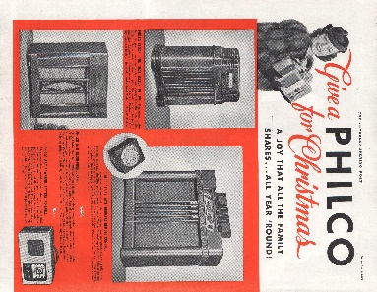 | Philco_Ad_Sat_Eve_Post_Feb_18_1939.jpg | Saturday Evening Post Philco Advertisement Featuring the Mystery Control. (February 18, 1939, p. 3)
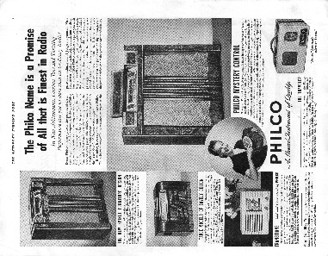 | Philco_Ad_Sat_Eve_Post_Dec_9_1939.jpg | Saturday Evening Post Philco Advertisement Featuring the Mystery Control (December 9, 1939)
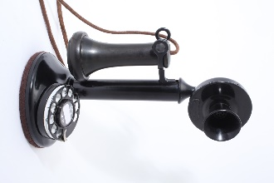 | WE_50AL_01.JPG | The 1919 Western Electric 50AL “Candlestick” Dial Telephone, the first dial phone on the Bell Network.
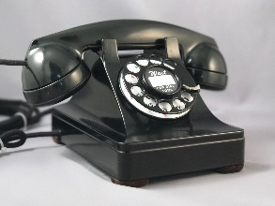 | Western_Electric_302_img02.jpg | The 1937 Westarn Electric 302 dial telephone. Industrial design by Henry Dreyfuss.

