BUXTON COLLECTION
home | explore | about | acknowledgments | contact

Blue Orb Inc. OrbiTouch
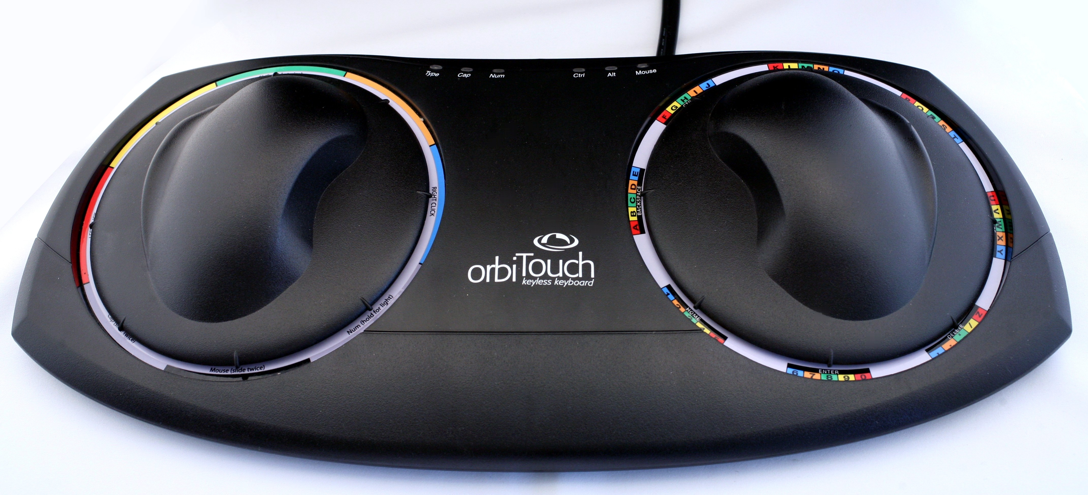
Short Description: On the one hand, this device has the overall footprint of a keyboard, and it is used to enter text. And yet, it is two wide, flat, spring-loaded, self-returning joysticks, which are used to enter characters, rather than the keys that we typically employ. To add to the unconventional nature of this device, one enters text via these two joysticks by means of something called radial menus, one for each hand. And, in keeping with many keyboards, such as those with an integrated touch pad, the OrbiTouch also enables mouse like capabilities, such as pointing and selecting, also by means of one of the joysticks.

Bill Buxton’s Notes
Keyboards, Joysticks and Hierarchic Radial Menus

Introduction
When you first look at this device, you might guess that it is some kind of keyboard. It even says so on the box and on the device itself. The keyboard-like footprint might reinforce this notion, as might the alphanumeric characters in the grey ring around the circular orb on the right-hand. On the other hand, if this is a keyboard, where are the keys?
Reading the labels more carefully sheds light on the paradox: there are none. This is a “keyless keyboard.”
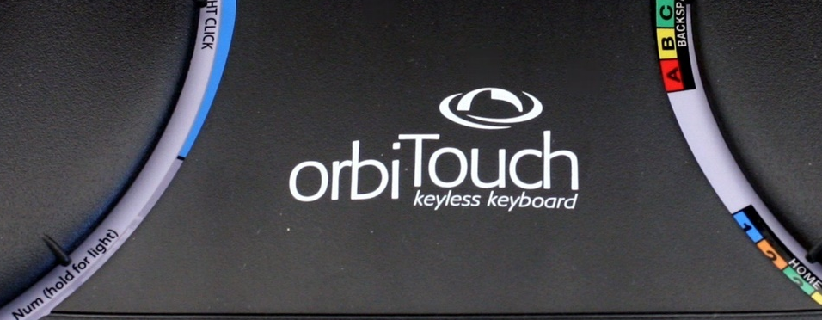
Yes, this is a contradiction in terms. But it is just such curiosities that make devices like this potentially interesting. Hence, we shall take a reasonably deep dive to see what might be revealed.
Let’s start by trying to understand what the rationale was for landing on this particular design.
The orbiTouch was developed by an industrial engineering doctoral student at the University of Central Florida, Peter McAlindon. His goal was to develop a means of text entry that minimized hand and wrist motion. The intent was to reduce the incidence of repetitive stress injury. A fair bit of research was undertaken between initial concept and commercial release. This can be accessed online, and doing so is a worthwhile exercise.
Let us now turn our eye to the physical device in order to get a sense of where all of this landed.

The Physical Device
The orbiTouch is dominated by two large circular “orbs.” To my eye, their form initially practically screamed out, “I am a rotary control - Turn me!” However, appearances can be deceptive. Rather than dials, the orbs turn out to be a pair of a joysticks of a particular type.
Rather than the stick-tilting motion typical of most, these “joysticks” are operated by moving them along the horizontal plane. In this they are a close cousins of the Altra Felix and KA Design Turbo Puck, both also in the collection. However, in contrast with the Felix and Turbo Puck, whose handles are “floating” (if you let go, they remain in the position where you released your grip), the orbs are “self-centering.” That is, when released, internal springs return the orbs to their neutral central “home” position. In this, they behave much like the Gravis joystick in the collection, for example.
At a finer level of detail, the orbs are specific class of joystick: “8-way joy-switches”. The term”8-way” indicates that only movement along the 8 main axes of the compass are sensed. As to the word “switch”, think of each orb as 8 switches, any one of which can be turned on by moving the orb in one of the 8 directions. (Conversely, they are turned off when the orb is released and returns to home position).
Unlike an analogue joystick, such switches do not, and cannot, report how far or fast the orb has moved in any particular direction, nor how much pressure might be applied in the process. While limited, joy-switches provide a less complex and lower cost solution that are appropriate in situations where this additional data is not needed. There are several examples of joy-switches in the collection, especially video game controllers. One of the most iconic examples is the Atari CX-40 controller, which is a 4-way joy-switch.
To recap, the orbiTouch is a bi-manual device for entering text by means of two orb-shaped planer-moving 8-way self-centering joy-switches.
Having swallowed that mouth-full, let us now explore how text is entered using such a transducer.

Entering Text
In general, a character or function is input by moving the two orbs. Which character or function depends on the direction (if any) each of the orbs has moved. For example, if both the left and right orb move west (left), the character “a” is entered. On the other hand, if the right orb again moves west, but the left one east (right), then the character input is “e”.
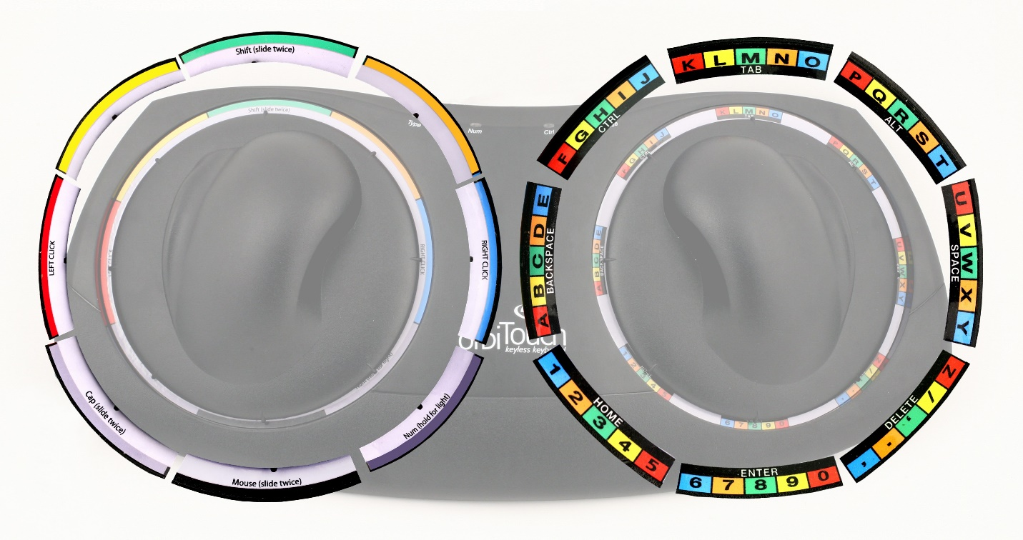
How or why this is the case can be explained with the help of some images. For easier reading, the figure below shows the labels around the orbs in an exploded view. Notice that for both orbs, there is a label segment for each of its 8 directions. Since the example discussed entering an “a” and an “e”, each of which involved the right orb moving west (left) let’s look at the associated label segment in even more detail.
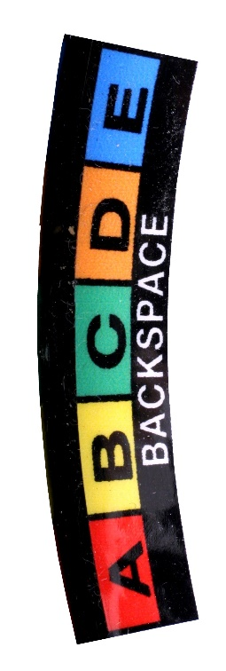
Like all of the label segments for the right orb, this one consists of six areas containing text, each with a distinct background colour: red, yellow, green, orange and blue for the letters A through E, respectively, and black for the region containing “BACKSPACE”.
Now look again at previous image and notice that each of these colours matches the label associated with one of the directions of the left orb.
Text is entered using a two part process.
- Moving the right orb to the left/west specifies that you are going to enter one of: a, b, c, d, e, or BACKSPACE. (Like most keyboards, despite the labels on the key-caps being upper case, lower-case characters are entered unless the shift key is depressed.)
- Moving the left orb in the direction whose label corresponds to the background colour of the desired character causes that character to be entered.
Hence, with the right orb held in the left/west position, one can enter the sequence, “abcde”, followed by a Backspace, by sequentially moving the left orb west (red), north-west (yellow), north (green), north-east (orange), east (blue) and south (black).
The same technique can then be used to access all the characters and commands found in the right orb’s labels.

Special Modes
There is one thing to add at this point: While entering printing characters always requires the use of both orbs, some actions can be performed using the left orb only. This can be inferred by the text that accompanies some of the left orb’s labels. For example, moving the left orb north (green) in quick succession (analogous to a double-click on a mouse), indicates that SHIFT will apply to the next character entered. Likewise, doing the same thing in the south-west (grey) direction applies the Caps Lock mode, i.e., SHIFT will be applied to all subsequent entries until the mode is cancelled.
These one-handed special modes/functions are summarized in the image below.
Of these, the only one that I want to discuss at the moment is the ability of the orbiTouch to switch from entering text to controlling the screen cursor. This is done by moving the left orb south (black) twice in quick succession. When this is done, the right orb controls the cursor movement – the cursor moves continuously in the direction that you move the orb. In this, any doubts that you had about me characterizing the orbs as joysticks should disappear, since this cursor control is classic joystick behaviour. One issue of note is that the label describes this as “mouse” not “joystick”, which while understandable, is incorrect.
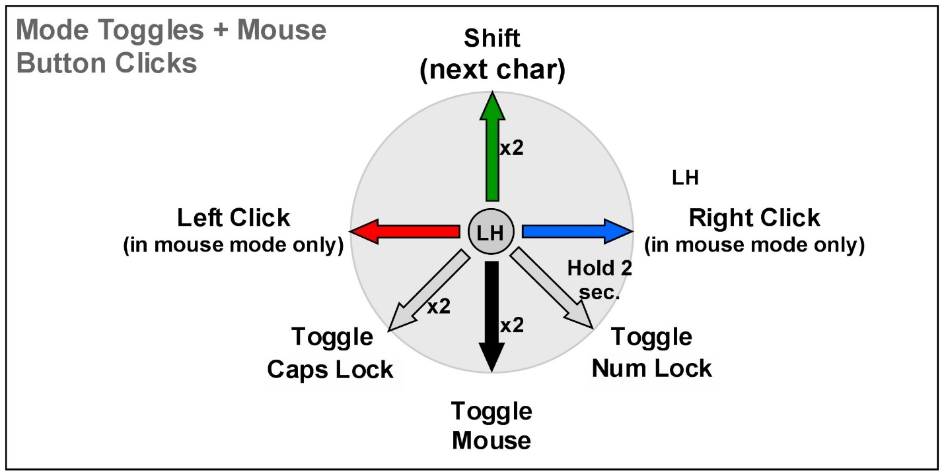
Finally, before moving on to the next topic, note that while the right orb controls the movement of the screen cursor in mouse mode, movement of the left or left/west or right/east is taken as a left and right mouse button press, respectively.
Remembering that the premise here is that the hands don’t have to move from the orbiTouch in order switch between typing and pointing tasks. But that doesn’t mean that the overhead in switching between the tasks is removed. One type of overhead is just substituted for another. And, the moded nature of the orbiTouch means that the option of parallel pointing-typing actions are eliminated. Rather than criticism, I mention these points to indicate the need to be mindful of the trade-offs and consequences of different design decisions - consequences that the designer should be aware of.

Going Meta: What’s Really Going On?
I want to approach doing so by stepping back, and approaching the underlying method of “typing” by going “meta”. That is, I want to jump up a lever of abstraction, beyond the physical device (for the moment), and explain what is going on at the conceptual level.
The rest of the text is in much rougher form ….
What will be revealed, if we do so, is that text is entered by means of the parallel use of two 8-direction radial menus.
So what is a radial menu? These are the neglected cousins of the linear menus that populate conventional graphical user interfaces. The difference is that one makes a selection by the direction of movement, rather than the distance (as in the case with linear menus). It turns out that people can learn these quickly if the directions correspond to the 8 main points of the compass. For example, in a program menu, moving up (North) might mean Print, down (South) could mean Save, and moving down to the right (South East), Save As. Like linear menus, these menus can also be hierarchic. So, for example, after moving South East in order to specify Save As, a stroke to the left (West) might mean that it should be saved as a PDF file, whereas it would be saved as a Plain Text file if the secondary connected stroke was to the right (East).
The reason for this brief tutorial on radial menus is that they pretty much define at the conceptual level how text is entered using the orbiTouch. The eight directions that you can move the orbs defines the menu item selected. And, by having the actual output depending on the combination of the selection made by each of the two orbs, the device can perhaps be best described as entering text using a two-level hierarchic radial menu, where menu selections are made using two planar moving 8-way joy switches. That is quite a mouth-full, and it has taken all of the text above to bring us to the point where there is a reasonable chance that it makes sense. And we still haven’t gotten into the details!
it uses hierarchic (2-level) radial menus, but where the hierarchy is space multiplexed, rather than time multiplexed. That is, rather than doing one menu selection after the other, you do them simultaneously, by using a different hand to articulate the selection from each of the two menus. (While the text on the description is sparse still, look at the training cards, etc. and the photos on the page.)
At the level of the mental model, there is no question in my mind (actually, I shouldn’t say that, because I am supposed to be an objective researcher who needs empirical data to inform decisions, but what the hell!) that you could give someone who knew how to use this device two isotonic joysticks, such as used with a video game controller, and they would be able to enter text just as fast as with this device. Furthermore, I am sure that if one had a slate capable of sensing both touch and stylus simultaneously, I am certain that the skill would transfer equally to using a touch radial gesture in the non-dominant hand, and stylus (or touch) radial gesture with the other.
At the basic level, it is a 2-level radial menu, but where each level is operated independently and quasi-simultaneously by a different one of the operator’s two hands.
Level 1: Right Hand
- This lets the operator select one of eight regions
- The label for each region consists of 6 characters (5 printing and one “special)
- In selecting one of the regions, one is not selecting any one of the characters of that region; rather, they are just indicating that the character that they want is one of the six in that region
- Each of the characters in a region has a different background colour: blue, orange, green, yellow, red and black.

Level 2: Left Hand
- This lets the operator select one of eight regions
- Each region is labeled by a single colour
- Among the colours that label the eight regions are the same ones used as character background colours in the regions of the right-hand control: blue, orange, green, yellow, red and black
- By the left hand selecting one of these six colours, one indicates which character is to be entered from among the six characters in the region indicated by the right hand – the selected character being the one whose background colour corresponds to the colour selected by the left hand.
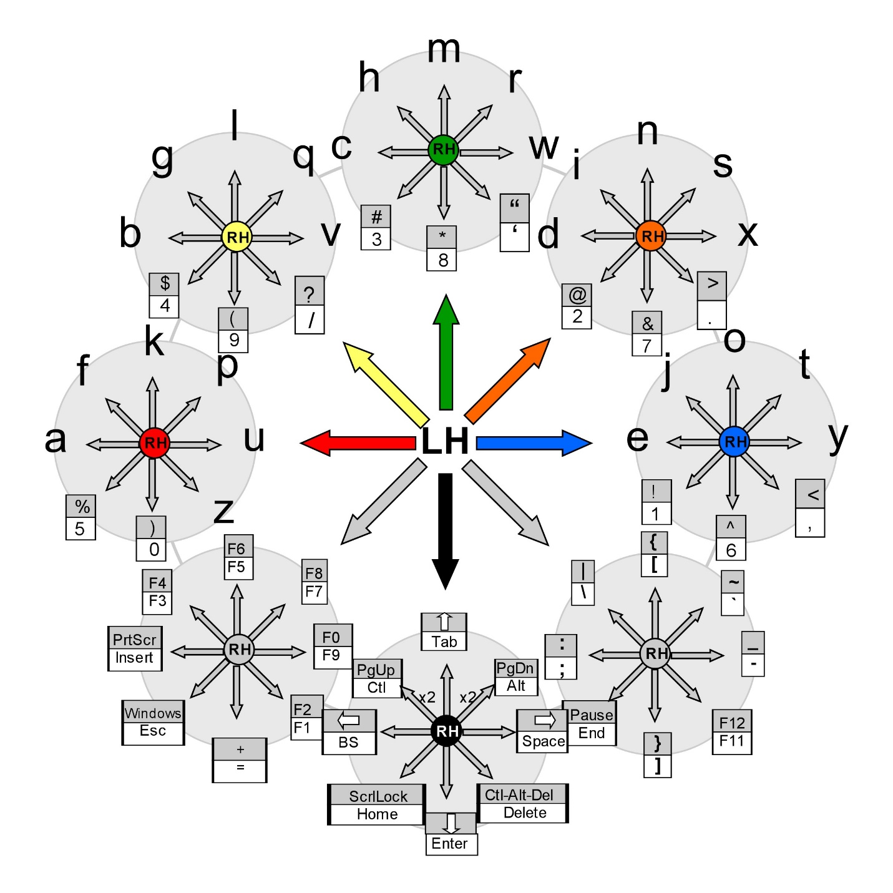

Hence, there are two 8-way, single level radial menus used. I believe it fair to say that it is, nevertheless, a 2 level radial menu, since both need to be used in order to enter one token.
In actual fact, things are more complex, since none of the above covers issues such as all of the special character, punctuation, etc., that do not appear on the labels of the right hand. To keep things brief, this is why only 6 of the left-hand menu options are used in what is discussed above. The other two options are needed to fill in the gaps. And, even then, the device resorts to something like double-clicks to get special modes and capabilities. For example, double clicking the black (south) region of the left hand turns the right-hand dome into a pointing device, i.e., a mouse substitute for pointing, etc.
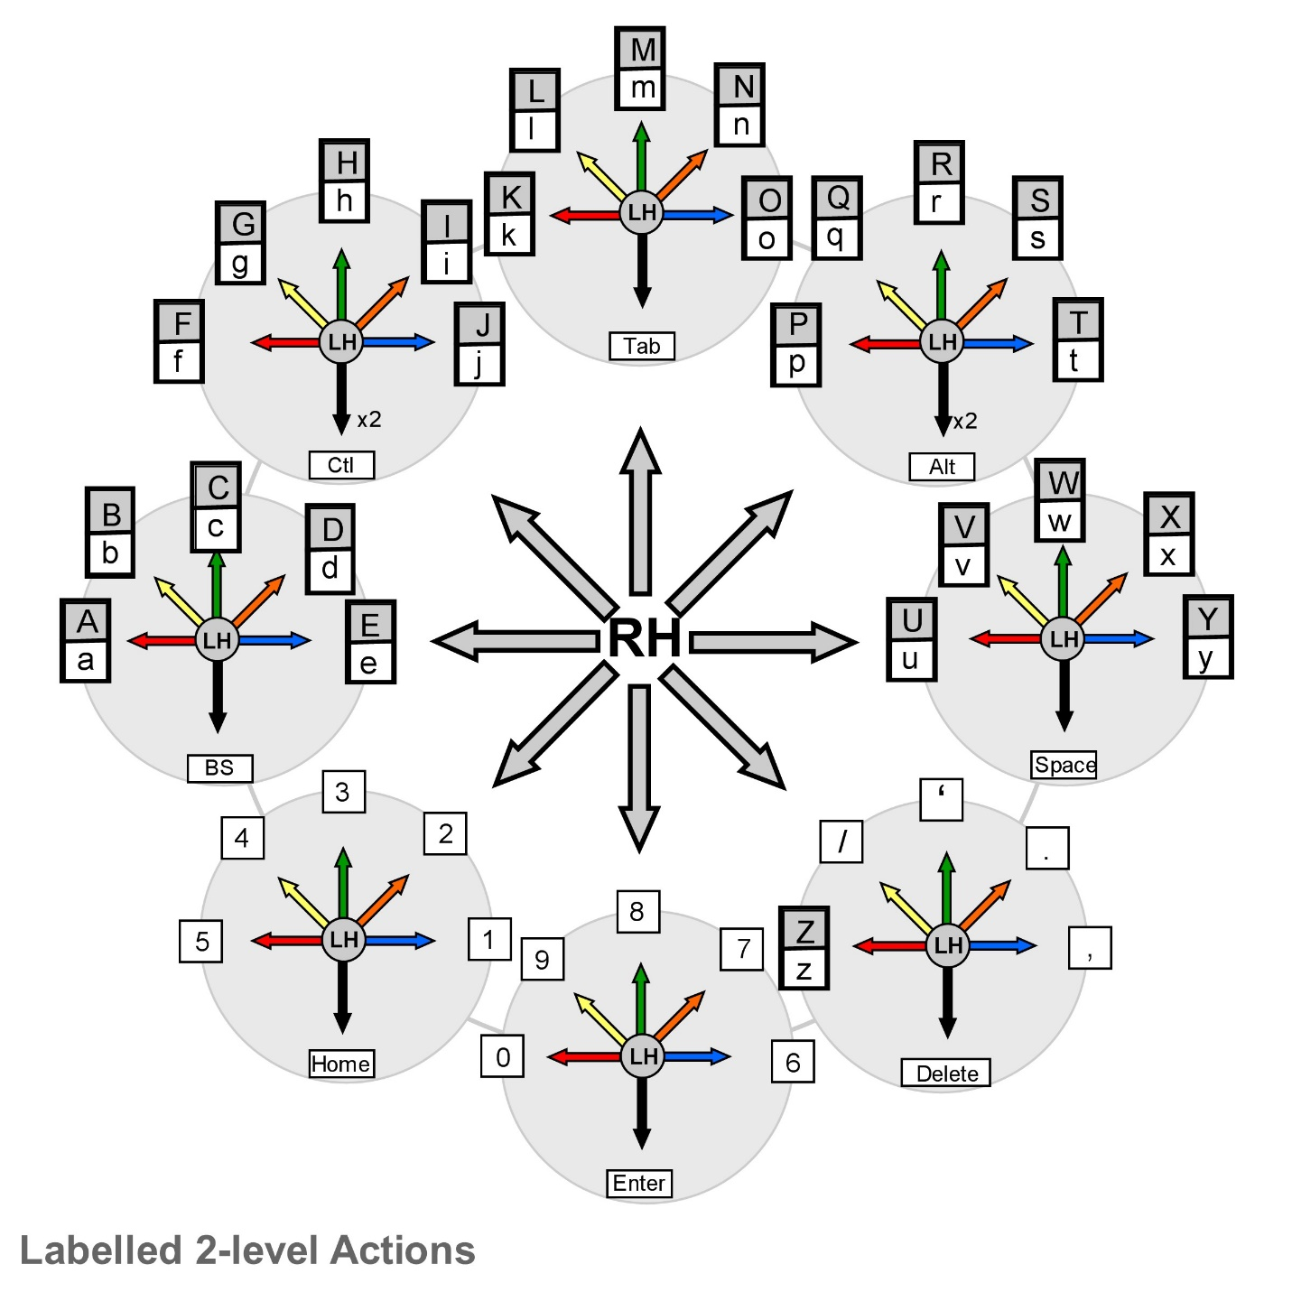
I went through the – as it turned out – interesting exercise of translating the two parallel depth-1 radial menus of the orbiTouch UI into two different depth-2, breadth-8 hierarchic radial menus. You can see them in the attached images. The one assumes that the LH “dome” as the first-level selection, and then make the second-level selection with the right-hand dome. The other does the opposite, i.e., the right-hand dome selection is the first level.
It is interesting to compare the two with each other, as well as with both the labeling on the orbiTouch and the Quickstart documentation:
- The RH level-1 version seems easier to get rudimentary understanding compared to the LH due to clustering of letters and numbers on outer menus.
- Likewise, for the special characters that are the upper case of the numbers
- The physical device is fine for letting you hunt-and-peck, so to speak, for characters, but it is useless for numbers, and most special characters.
- The documentation provided with the Quick Start (attached is not especially useful in terms of providing heuristics for memorization.
- While the orbiTouch certainly uses radial menus, it decidedly does not employ marking menus. One of the key things missing is the ability to check and correct before committing to an input, and the lack of ability to backtrack to the start, and therefore abort without entering anything.
- One thing that I have learned from this exercise is the difference that results due to having self-returning joysticks. Gestures don’t have that attribute. It matters esp w.r.t. the last point.

What I like about this story, is how looking at something seemingly very different at the right level of abstraction, teaches us/me something new about something I was supposed to be an expert in. That is, that 2-level hierarchic marking menus can be achieved by two simultaneous single-level MMs. This is why I have the collection, and why I love what I do. There is still delight, despite being a 63-year-old geezer grandfather.
The orbiTouch Keyless Keyboard was first known as the Keybowl, and the company was formerly known as Keybowl Inc., and then Blue Orb Inc.
Device Details
Company: Blue Orb Inc. | Year: 2002 | Original Price (USD): $695.00
Degrees of Freedom: 4
Dimensions (L x W x H): 482.6 x 228.6 x 74.2 (mm) / 19 ¼” x 9” x 2 7/8”
Key Words
Primary: Joystick
Additional: Keyboard
Links
- Web link

- pdf file

- powerpoint

- you tube link

Photo | Image | Caption
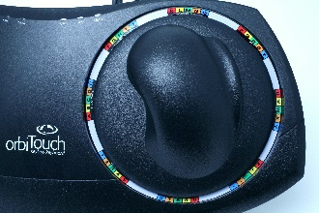 | orbiTouch_0890c.JPG | Detail of the right Orb showing labels.
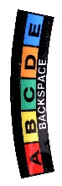 | orbiTouch_0932b.JPG | The left “9 o’clock” menu for the right orb.
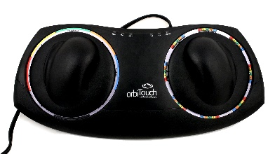 | orbiTouch_0949.JPG | Top overview of the orbiTouch
 | orbiTouch_0949b.JPG | A Keyless Keyboard!
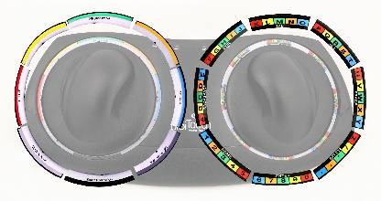 | orbiTouch_0950c.jpg | Exploded view, highlighting radial menu labels for both orbs.
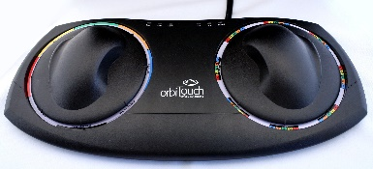 | orbiTouch_1273c.JPG | Elevated front view of the orbiTouch
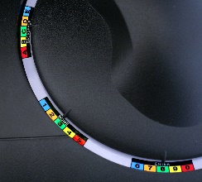 | orbiTouch_1277.JPG | Detail shot showing lower-left menus of the left Orb
1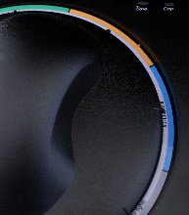 | orbiTouch_1281.JPG | Detail shot of Right Click / Blue menu at 3 o’clock of the left orb.
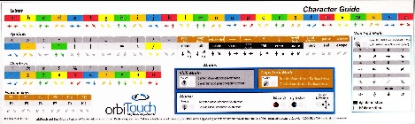 | orbiTouch_Character_Guide.jpg | The overall “cheat sheet”, summarizing the full functionality of the orbiTouch
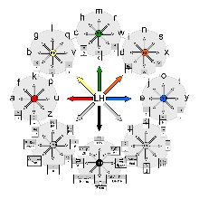 | orbiTouch_orb_MM_framework_LH.jpg | Schematic of the left-hand-centric bi-manual hierarchic radial menu structure of the two orbs.
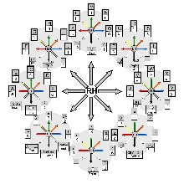 | orbiTouch_orb_MM_framework_RHshift_sparse.jpg | Schematic of the labelled right-hand-centric bi-manual hierarchic radial menu structure of the two orbs.
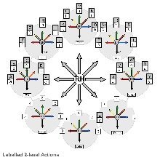 | orbiTouch_orb_MM_framework_RHshift.jpg | Schematic of the full right-hand-centric bi-manual hierarchic radial menu structure of the two orbs, including those not labelled on the device.
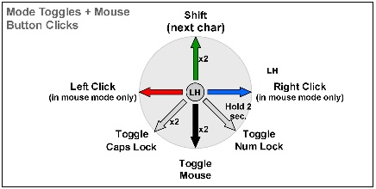 | orbiTouch_orb_MM_Mode_Toggle.jpg | Mode Toggles + Mouse Button Clicks
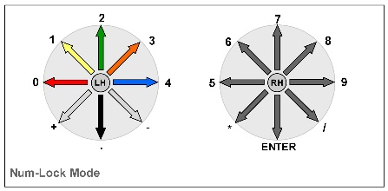 | orbiTouch_orb_MM_Num_Lock_Mode.jpg | Numeric Lock Mode
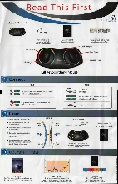 | orbiTouch_Quick_Start_sheet.jpg | orbiTouch Quick Start Sheet

